**ELEVATE LABS**

**DATA ANALYTICS INTERNSHIP TASK-6**

**\*DATASET :- sales.csv from KAGGLE**

**\*describe table**

**\*Sales table**

**1.Extract year,month from order_date**

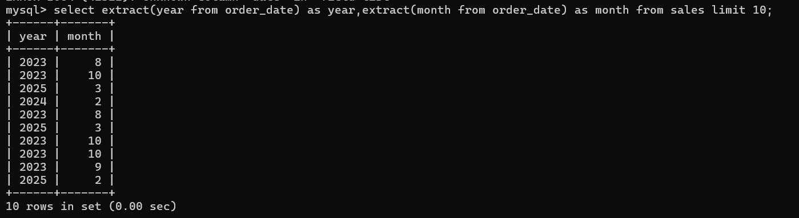

**3.Top 5 month by sales**

**4.Limit to specific year**

